CO2-ASSESSMENT TOOL-DEBUGGING QUESTIONS
NAME: KONGALAVEETI VENKATA MALLIKHARJUNA REDDY
REG NO:192525109
COURSE NAME : DATA STRUCTURES
COURSE CODE : CSA0307

QUESTION 1:

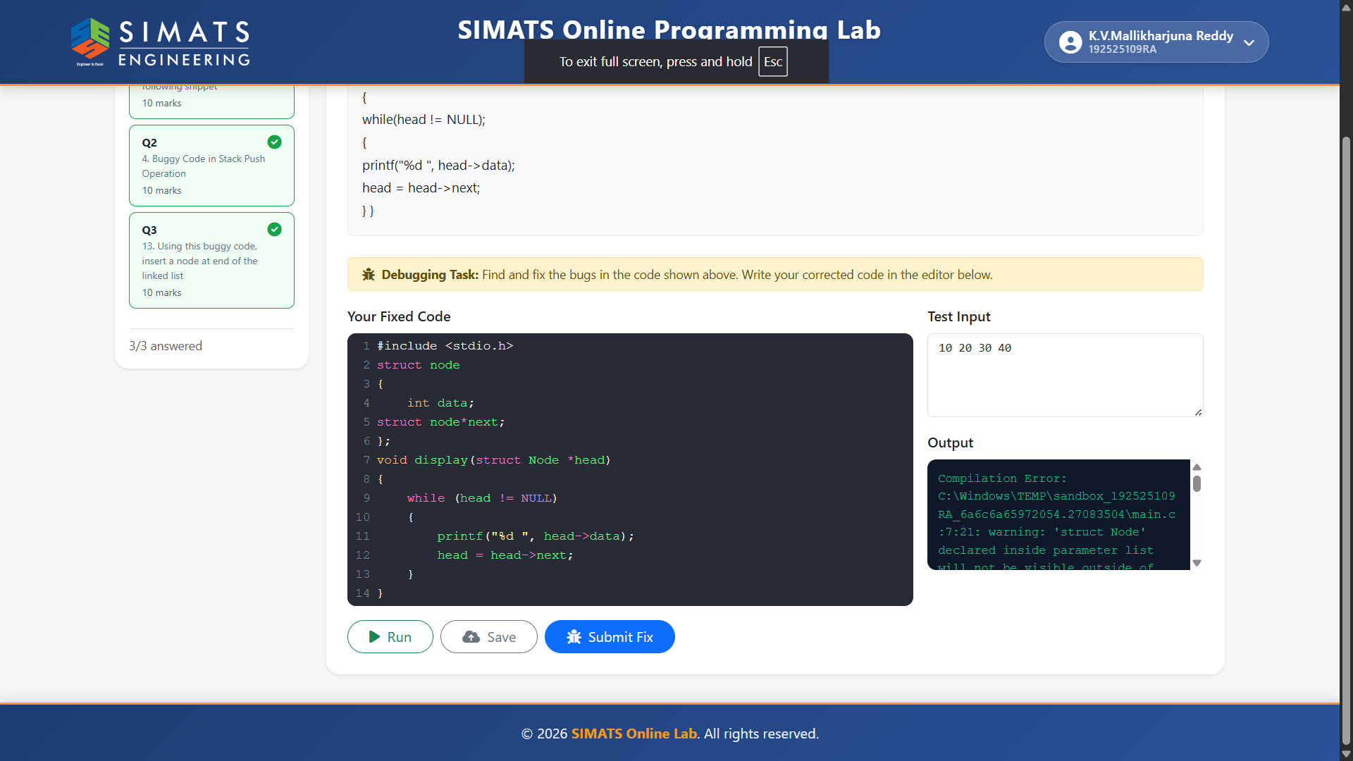

QUESTION 2:
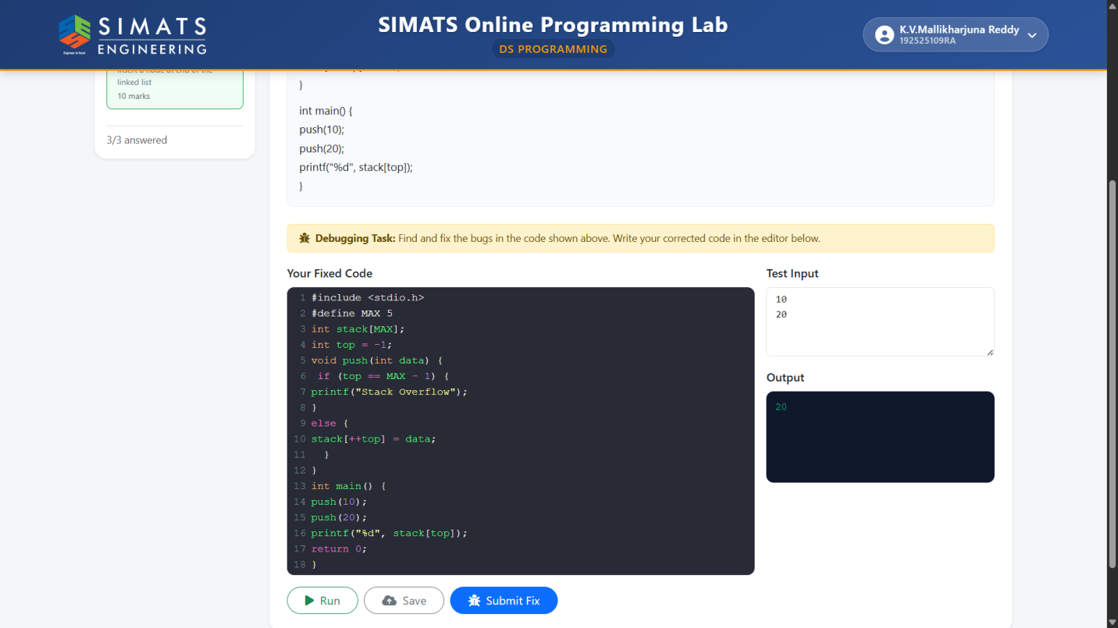

QUESTION 3:
